How to put web app code on Azure Web app :

Refer : <https://docs.microsoft.com/en-us/azure/app-service/app-service-deploy-ftp>

1. Create an empty web on azure portal :

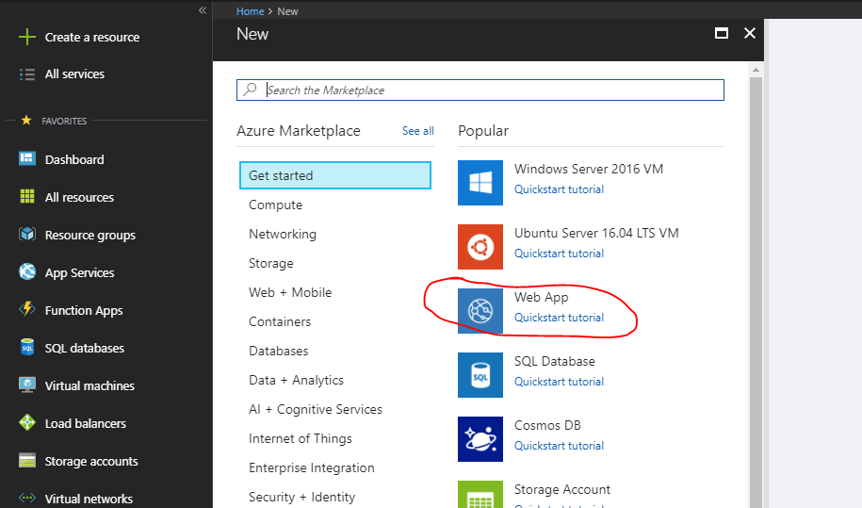

Note step number 2 to 5 is only user full if you have FileZilla software installed don your machine , if not then move to step 6 directly

1. Once the web app is created , go to deployment credentials options :

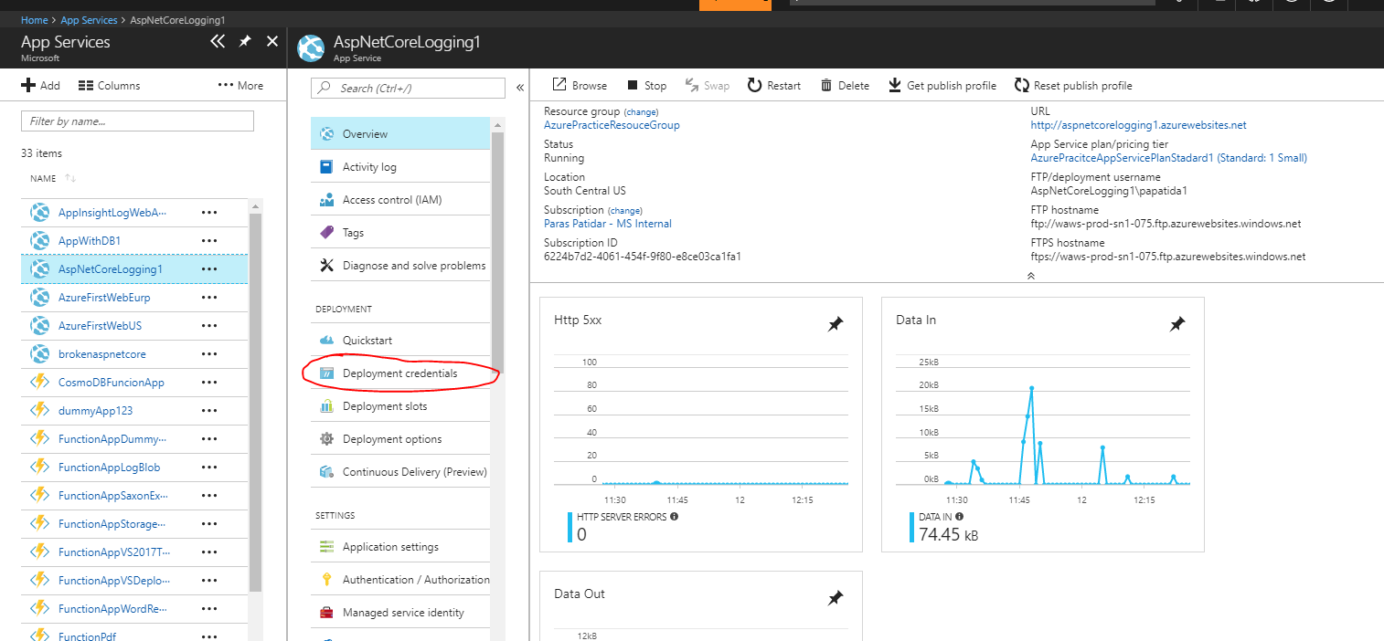

1. Set the user id and password for FTP deploye :

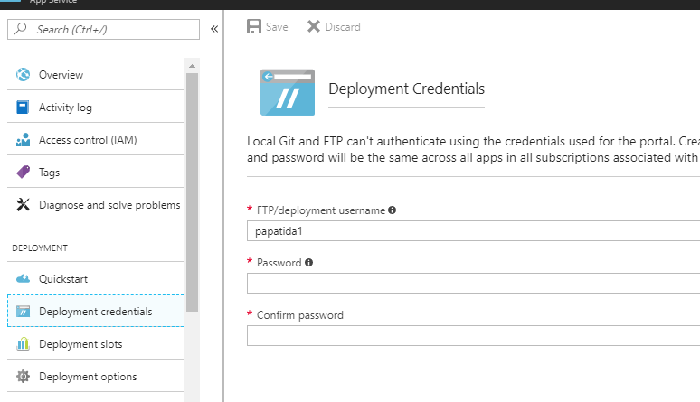

1. Go to overview option of that Web app :

Note the User name , which is like <webappname>\<username>

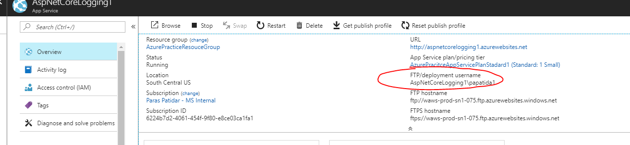

1. Note the FTP deployment address :

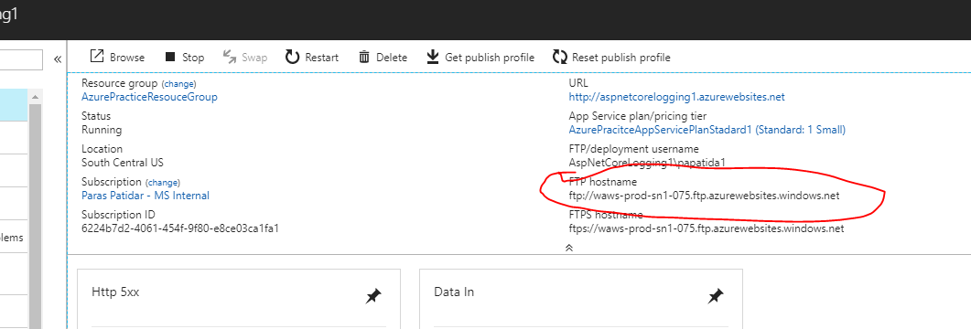

1. Now we have 2 ways to deployed it :
   1. KUDU
   2. FileZilla

As you will not be able to install FileZilla , thus we shall go with kudu option :

1. Open the kudu console of web app from advance tool option , it will open a link for kudu of your web app

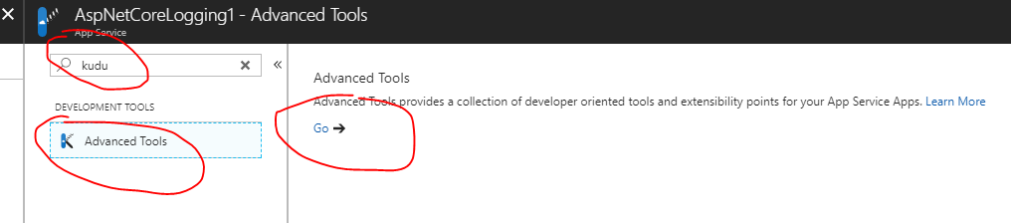

1. Go to debug console🡪 CMD

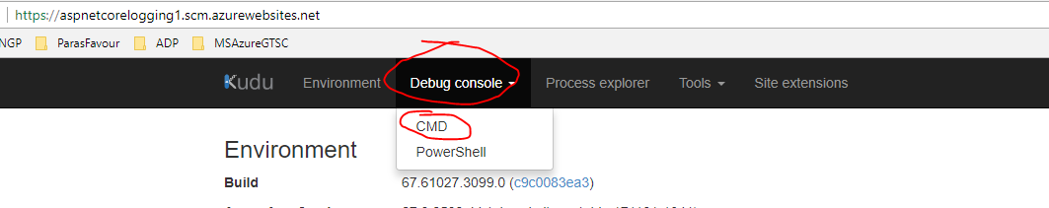

1. Click on folder site -- > wwwroot and reach to wwwroot folder :

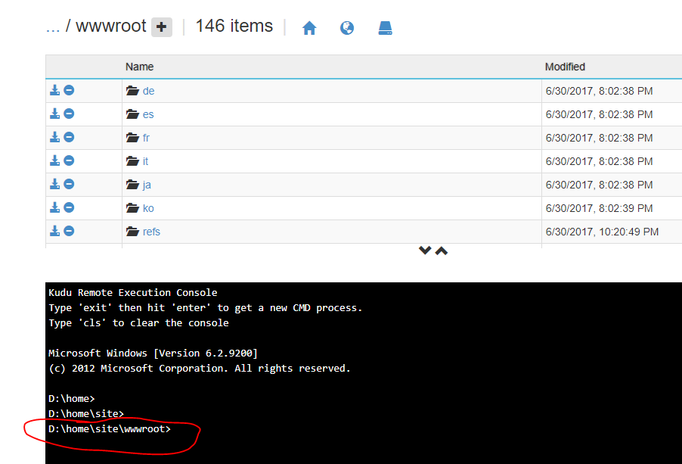

1. Now from out visual studio , publish the application on some local folder lets say c:\publishedweb :

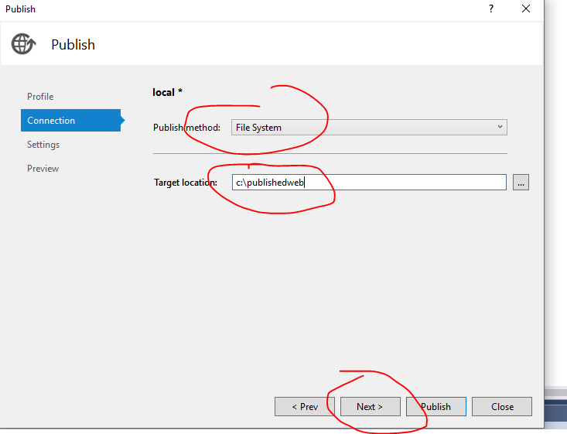

1. Copy all the files after publishing from folder c:\publishweb

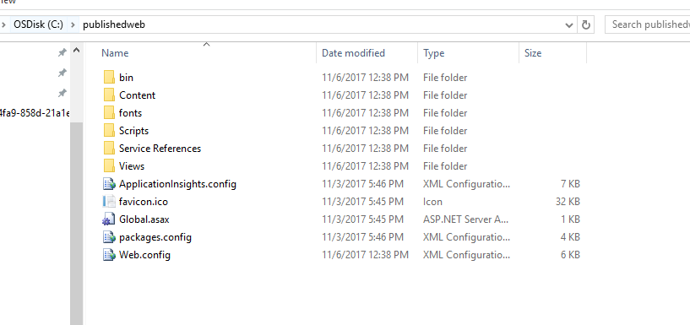

1. Paste them in wwwroot folder of Kudu , by drag and drop :

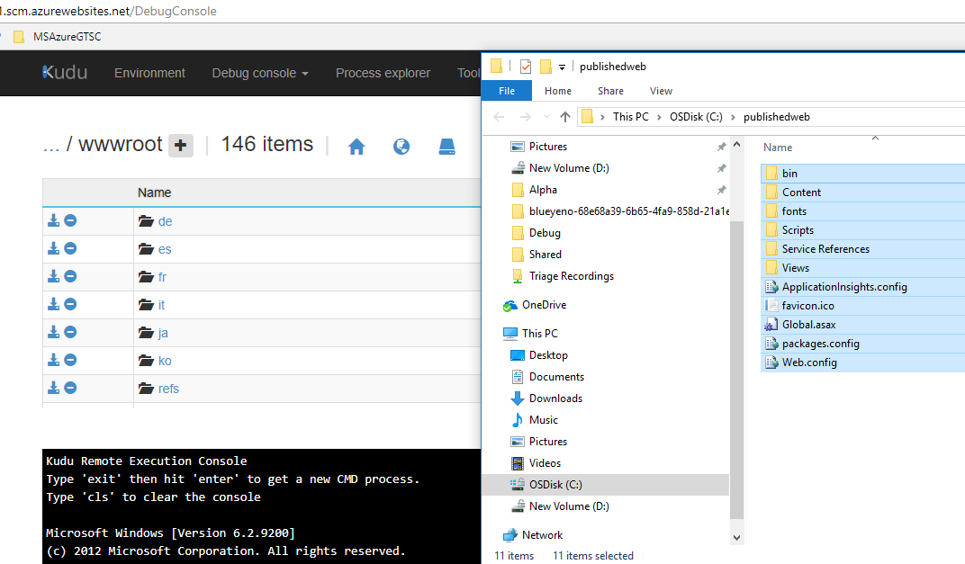

1. It will take few minutes
2. After that browse your azure web app as deployment is completed
3. If error occurs in web app, try to debug it as normal web app.